**UA CONNECTIVITY ANDROID APP**

**VERSION: V1.0**

**Contents**

1. Document Information
   1. Document Revision History
   2. Template owner and version
   3. Authorization
2. Introduction
   1. Project Introduction
   2. Purpose of the Document
3. Scope
   1. In Scope
   2. Future Scope
   3. Out of Scope
4. Risk, Assumptions and Dependencies
   1. Risk
   2. Assumptions
   3. Dependencies
5. Architecture Diagram
   1. Solution Diagram
      1. Front End Solution Diagram
      2. Back End Solution Diagram
6. Attributes to Meet Solution
   1. Front End Technologies
      1. Technologies used
      2. Software used
   2. Back End Technologies
      1. Technologies
      2. Middle Ware used
      3. Database used
      4. Software used
7. Web services Details
8. Target Devices and Browsers
9. Portability
   1. Mobile application
   2. Back End layer
10. Performance
11. Scalability
12. Testing Approaches
13. Non Functional Requirement
14. Pages in application
    1. Login
15. Document Information
    1. Document Revision History

|  |  |  |  |
| --- | --- | --- | --- |
| **Version No** | **Changed by** | **Revision Date** | **Summary of changes** |
|  |  |  |  |
|  |  |  |  |
|  |  |  |  |

* 1. Template owner and version

This Template will be reviewed by the owners on an annual basis. An intermediate review may be conducted at any time should it be deemed necessary by events either internal or external to UA Connectivity.

Publication of a new version of this Template will be controlled and communicated by the document owner.

The current version of this Template will be located on the [Enterprise content management system] .

* 1. Authorization

|  |  |  |
| --- | --- | --- |
| **Name** |  |  |
| **Title** |  |  |
| **Approved By** |  |  |
| **Approved Signature** |  |  |
| **Approved Date** |  |  |
| **Approved Version No** |  |  |

1. Introduction
   1. Project Introduction

We are proud to say that our modernistic way of truck hiring service and fleet solutions bestow the way people used to hire transport solutions and our mobile enabled technology.  We aim to

Deliver quality service at competitive price and back up every shipment with latest technology and

Outstanding customer service. Our partner operators are verified and trained to deliver a reliable

And trustworthy service to achieve a higher customer satisfaction, it’s for everyone. Our simple

Platform was created to make your life easier by allowing you to quickly book a truck and track

Your freight from pickup to delivery.

UA Connectivity was designed and engineered to be a friendly, easy to use platform and more

Importantly. We the UA Connectivity team, are always here to help and keep you informed every step

Of the way, via phone, email, chat or messenger. UA Connectivity is a place to find shipments based on

Your location and preferences and to manage your fleet. It’s a chance to eliminate time wasted at

Load boards and grow your business.

* 1. Purpose of the Document

The purpose of the project is to understand the core concept of the business. To, ensure the

Whole team understanding under same page. Also we have listed the technology and terminology across the project.

1. Scope
   1. In Scope

We have considered following pages in scope for this project.

|  |  |
| --- | --- |
| **S No** | **Page Name** |
| 1 | Registration Page |
| 2 | Login Page |
| 3 | Forgot Password Page |
| 4 | Change Password Page |
| 5 | Dashboard Page |
| 6 | Hospital services |
| 10 | Offers |
| 11 | Settings |
| 12 | Splash Screen |

* 1. Future Scope

Future Scope will be decided based on our discussion

* 1. Out of Scope

Future Scope will be decided based on our discussion

1. Risk, Assumptions and Dependencies
   1. Risk

|  |  |  |  |  |
| --- | --- | --- | --- | --- |
| **ID** | **Risk** | **Impact** | **Probability** | **Mitigation** |
| R1 | Delay in setting up the connectivity from mobile devices to application web services via Data Power | Team may not be able to test the mobile app on actual devices specific issues. | Medium | UA Connectivity and Gyrfalcon to work together and ensure the timely availability of required connectivity at Gyrfalcon Off-shore |
| R2 | Availability of test mobile devices | Impact on build and test activities. | Medium | UA Connectivity to ensure the timely availability of test devices at Gyrfalcon Off-shore |
| R3 | Authentication solution should be approved and finalized | Re-work due to security non-compliance | Low | UA Connectivity and Gyrfalcon to work closely with UA Connectivity Information Security compliance team acceptable solution |

* 1. Assumptions

All assumptions will be updated based on our discussion

4.3 Dependencies

* Wireframe
* Server
* Web services
* UX

1. Architecture Diagram
   1. Solution Diagram

Solution diagram cover end to end flow for our application.

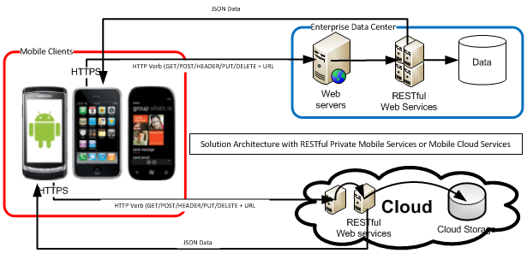

* 1. Front End Solution Diagram

Will be using Angular5 as JavaScript frame work and bootstrap as css frame work. HTML5, CSS3 and JavaScript technologies will be used. Below Mentioned is Architecture diagram.

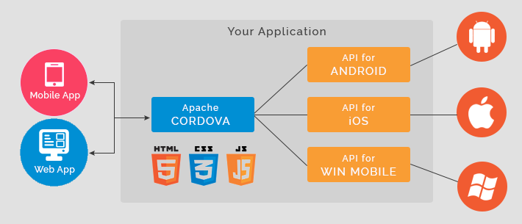

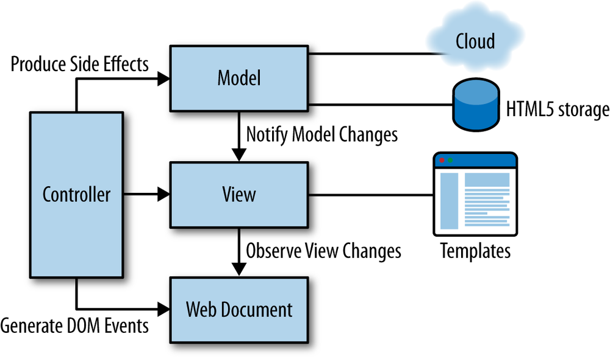

* 1. Back End Solution Diagram

Will be updated after finalizing Design

1. Attributes to Meet Solution
   1. Front End Technologies

Front end scripting languages are an essential subset of programming languages that perform specific functions within larger languages such as C# or Java. With the advent of HTML5, web application developers will have these scripting languages, particularly AJAX and Action script, incorporated in to the browser, as opposed to depending on 3rd party plug-ins.

Below is a summary of some of the Front End Technologies our developers have expertise in HTML, CSS, javascript, Angular5, NodeJs etc.

* 1. Technologies Used

|  |  |  |  |
| --- | --- | --- | --- |
| **Category** | **Vendor** | **Product** | **Version** |
| Mobile application framework | Apache | Cordova | V8.0.0 |
| Mobile application framework | Node.js Foundation | Node.js | V10.2.1 |
| web application framework | Google/Open Source | Angular | V6 |
| Mobile application framework | Open Source | SASS | V3.5.6 |
| Development Tool | Google/Open Source | Android SDK | V26.0.2 |
| web application framework | Html | Html | NA |
|  | css | Bootstrap.css | NA |

1. Software Used
   1. Back End Technologies

Yet to update

* 1. Technologies

Yet to update

* 1. Middle Ware used

Yet to update

* 1. Database used

Yet to update

* 1. Software used

Yet to update

1. Web services Details

Will be updated based on the design discussion with client.

1. Target Devices and Browsers

Yet to update

1. Portability
   1. Mobile application

Apache Cordova has a plugin architecture that is device and operating system independent; it enables developers to build mobile applications for IOS, Android and Windows Phone. Although the current mobile application is developed for Samsung devices running on Android, the framework can be ported to other mobile platforms.

* 1. Back End layer

1. Performance

The mobile solution will be designed in such a way that it will be able to complete all the navigation, moving around the application, displaying menus, accessing drop, down list etc. within one second with no activity taking more than two seconds. This will be only applicable to the screens that doesn’t have any associated back-end calls. The mobile solution will be able to complete all the business transactions except Track and Trace data retrieval operations, within 2 second with no activity taking more than one second for 95% transaction.

The loading and refresh time of the GPS Map will depend on the network connectivity to the Avon Mobility server.

Exceptional network issues may result in higher response time.

Assumes that the associated UA Connectivity back-end systems would return the data required for the track and trace transactions without any delay to meet this performance requirement.

1. Scalability

Existing hardware can be scaled up to meet additional load. In case the servers reach capacity, the architecture allows additional application servers in the load-balanced cluster allowing it to be scalable when the application is rolled out to additional areas. Moreover, the distributed architecture means that only a limited number areas will be running on a single instance allowing application to be highly scalable.

13.0 Testing Approaches

Testing includes system testing, integration Testing and Regression testing as part of End to End flow. System Testing would be covering the UI/Functional testing of the paperless application as well as admin module and web services testing for the new services. Integration testing of the application with upstream and downstream will not be carried out. Regression testing will be done to ensure the end to end working of all the existing paperless functionalities.

Further Details would be available in the Master Test Strategy. The Master Test Strategy will be placed in the below path in I drive.

14.0 Pages in Application

* 1. Home Page Flow

Application Flow:

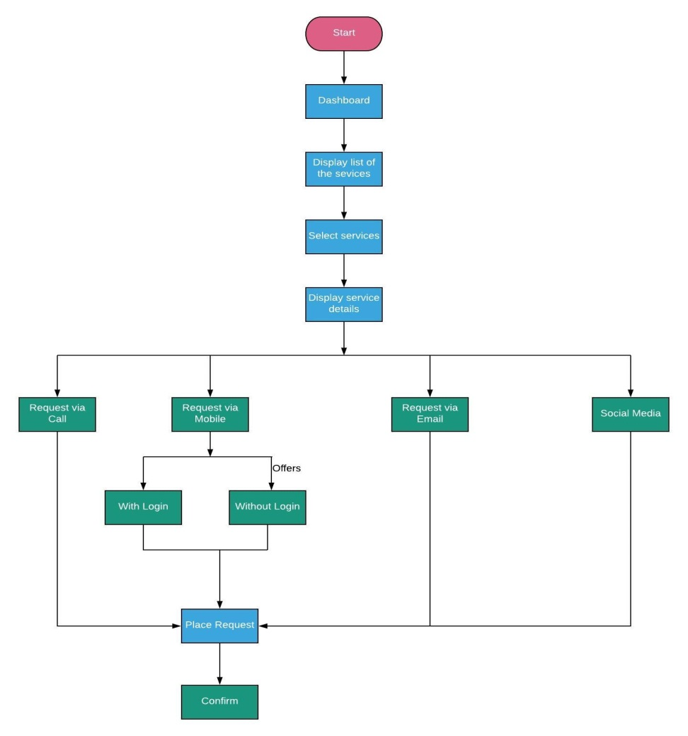

UA Connectivity Services

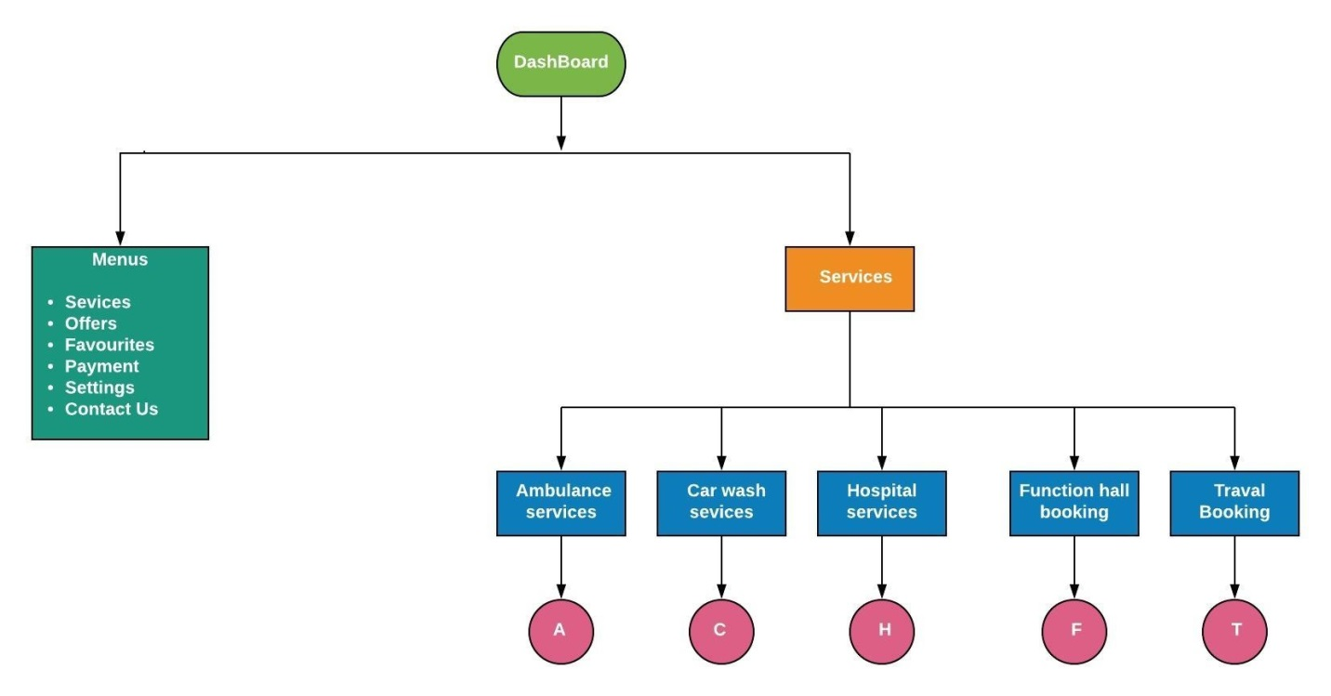

Home Services

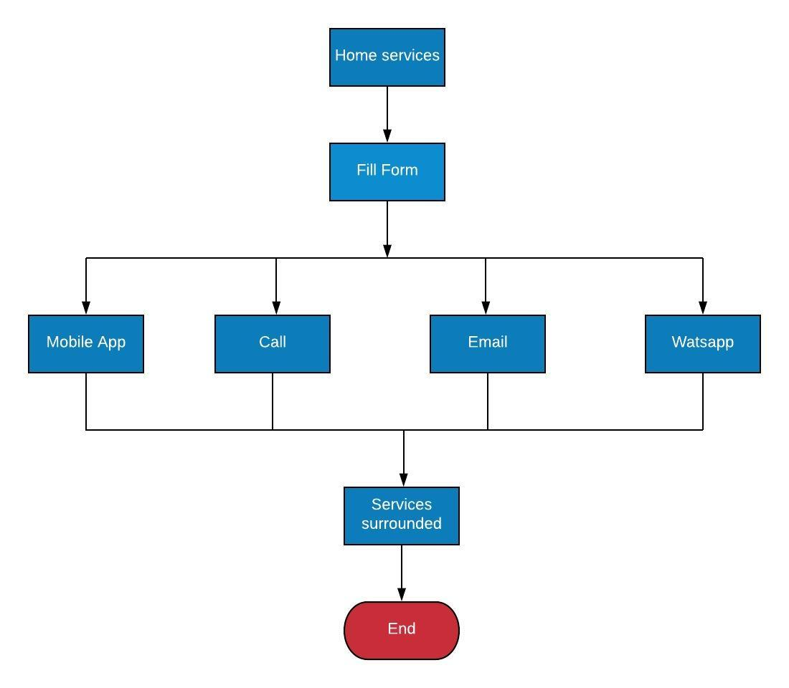

Hospital Services in Detail::

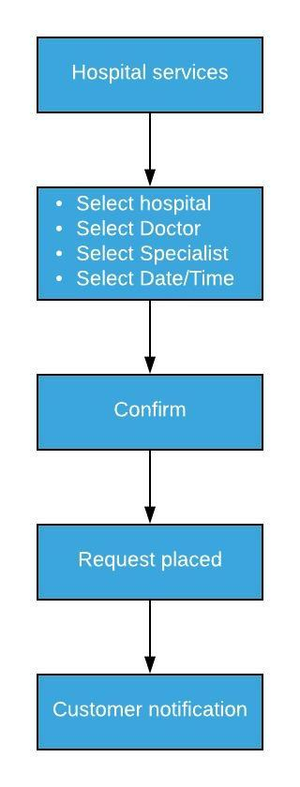

Login

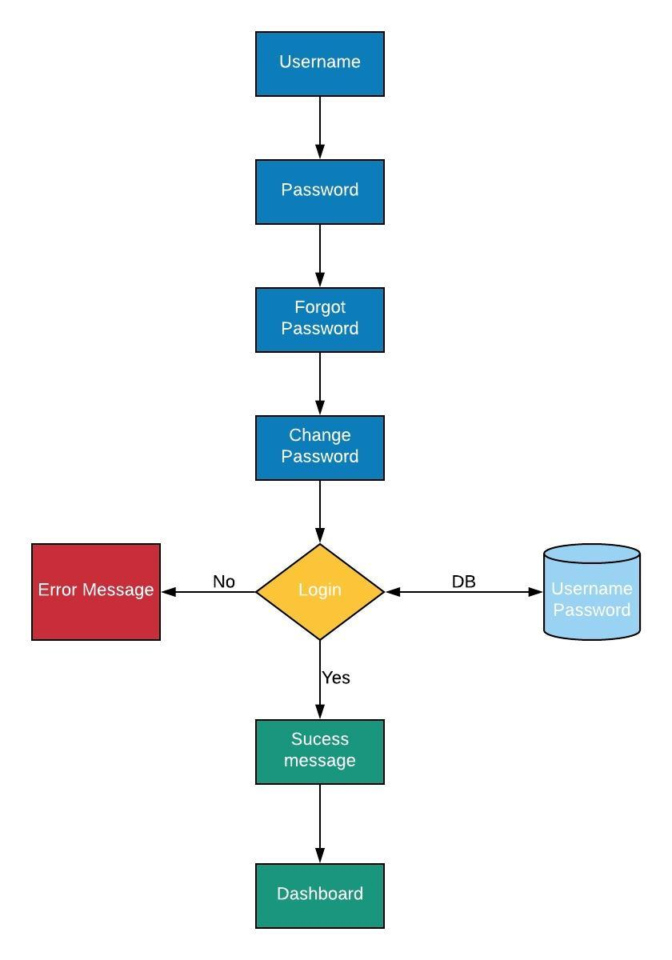

Forgot Password

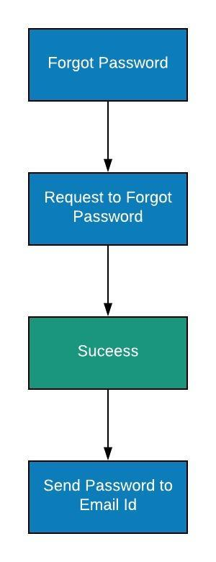

Change Password

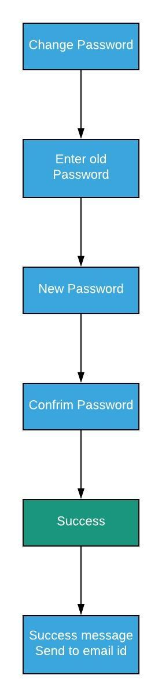

Payment

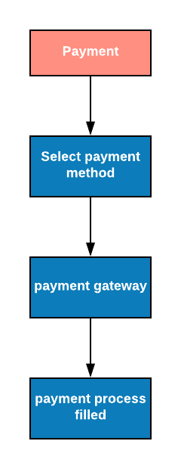

Setting  
 